Office of the County Assessor
Damian R. Lara
Albuquerque, New Mexico 87102
Office: 505-222.3700
Assessor@bernco.gov
www.bernco.gov/Assessor

April 14, 2026

Dear Friends,

On April 21, the New Mexico Department of Veterans Services (NMDVS) will be at all three of the Assessor’s protest sites to assist our veterans with filing protests or applying for exemptions.

Veterans who come to one of the sites will be able to receive certificates needed to apply for Veterans’ tax exemptions. Each veteran is entitled to a basic $10,000 property tax exemption. Disabled veterans can apply for, and receive, a property tax exemption equal to the percentage of their service-connected disability as recognized by U.S. Veterans Affairs.

The NMDVS and the Office of the Assessor have been collaborating for several years to ensure veterans who qualify are assisted in a prompt and respectful manner.

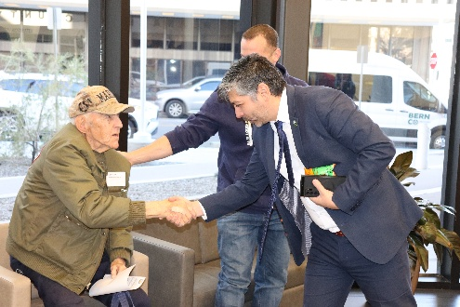
The protest locations are:

The Shoppes at San Mateo
6001 San Mateo Blvd, NE

Andalucia Shopping Center
5600 Coors Blvd, NW

Alvarado Square
415 Silver Ave, SW

The San Mateo and Coors satellite sites are open from 9 a.m. to 4:30 p.m. and are closed for lunch from Noon to 1 p.m. Alvarado Square is open from 8 a.m. to 5 p.m. NMDVS will be at each location from 9 a.m. to 3 p.m.

The Deadline to file a protest is May1 for all residential and non-residential property owners.

We hope to see you supporting our veterans on April 21.

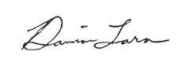
Sincerely,

Damian Lara
County Assessor
DRL/tt.

